[](http://www.pasaints.com/)

Alumni Newsletter

August/September 2016

**To get started:**

We need all our alumni to go into the website sign up for the information or you can send me the form that is located on the back and I will put it on the computer for you.

**Steps for the website:**

1. Go to [www.pasaints.com](http://www.pasaints.com)
2. Go to Join PA
3. Hit Join the PA Family
4. Hit Opt-In Form
5. Please fill out Last Name, First name, Address, Email Address
6. Mark on the groups PA Graduates (Alumni)
7. Put you Class Year
8. You have to enter the letters displayed first
9. Hit submit

**Form to be sent in by two ways:**

You can email me the form at [sabra@pasaints.com](mailto:sabra@pasaints.com) or you may mail it in to Patrician Academy Attn: Sabra Temple 901 South Mulberry Ave. Butler, Al 36904.

If you have any question about any of this please feel free to contact me at any time.

**General Information:**

Hello everyone. Your time as a student has gone, but we know you’re still a saint at heart. We are starting up an alumni page on the schools main website, [www.pasaints.com](http://www.pasaints.com) . The alumni association will be sending out newsletters; with information on the many of activities going on during each school year. I wanted to take this time to welcome everyone back to Patrician Academy, and “GO SAINTS”.

**Upcoming Events**

August 25: Kick Off Supper

August 26: PA vs Evangel (Away)

September 2: PA vs PA (Home)

September 9: PA vs North River (Home)

September 16: PA vs Clark Prep (Away)

September 22: PA vs Marengo (Away)

September 30: PA vs Southern (Home) **Pink Out**

**What has been happening around Campus!!**

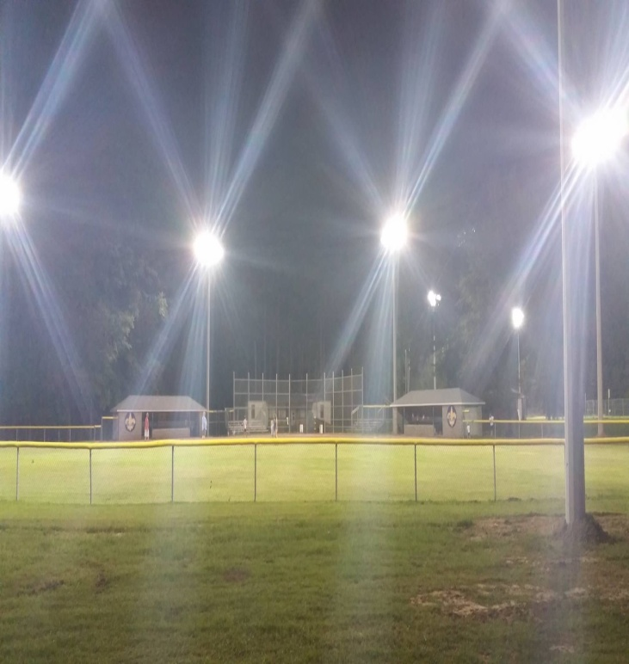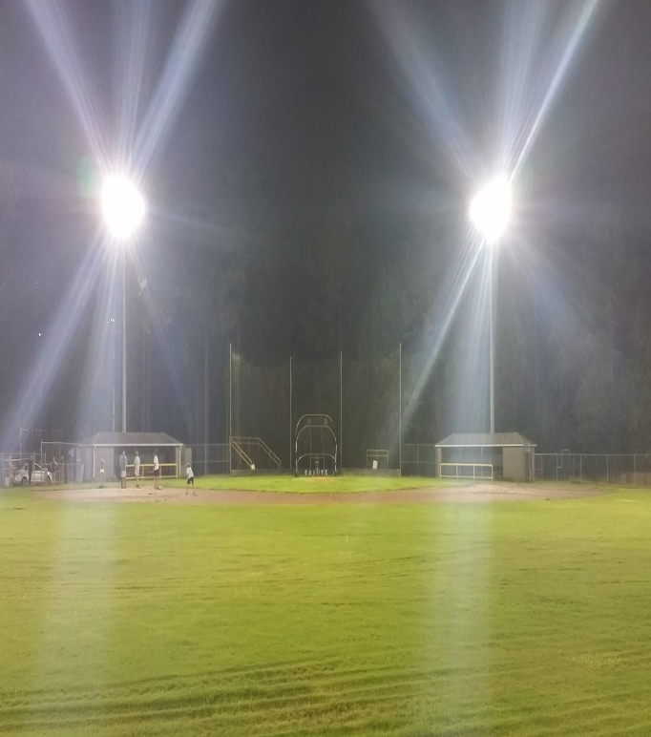

The school and sports club have put lights for the baseball and softball field. Here come more games!

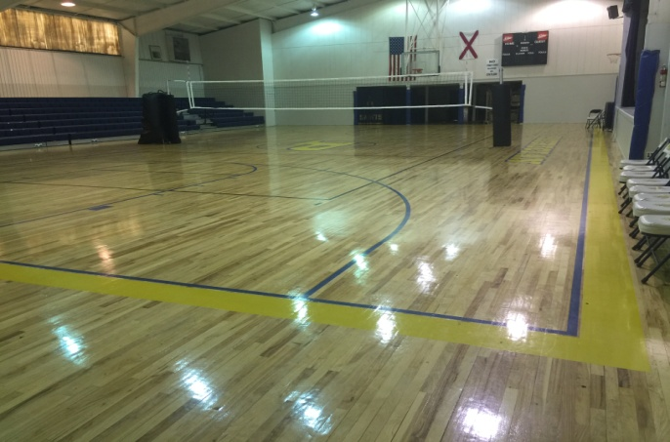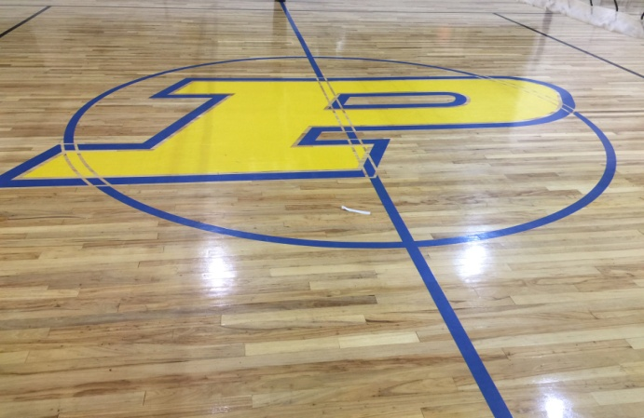

December of 2016 our Shipper and Shirley gymnasium floors were refinish. We even had our sits inside update, now they are navy.

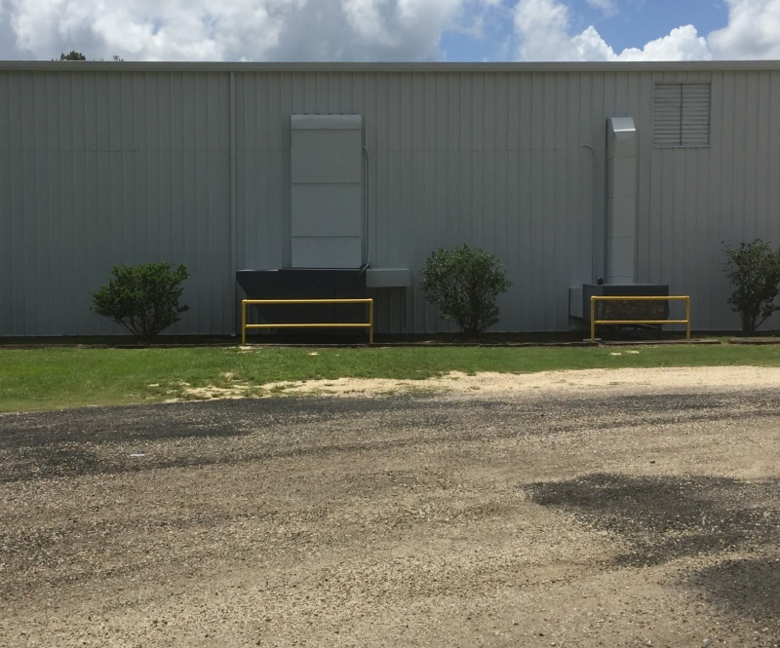

This summer the gym and the building of classes beside it was painted white and the doors was painted navy blue. It looks so much better now. When you come to town you need to come by the school and see the updates.

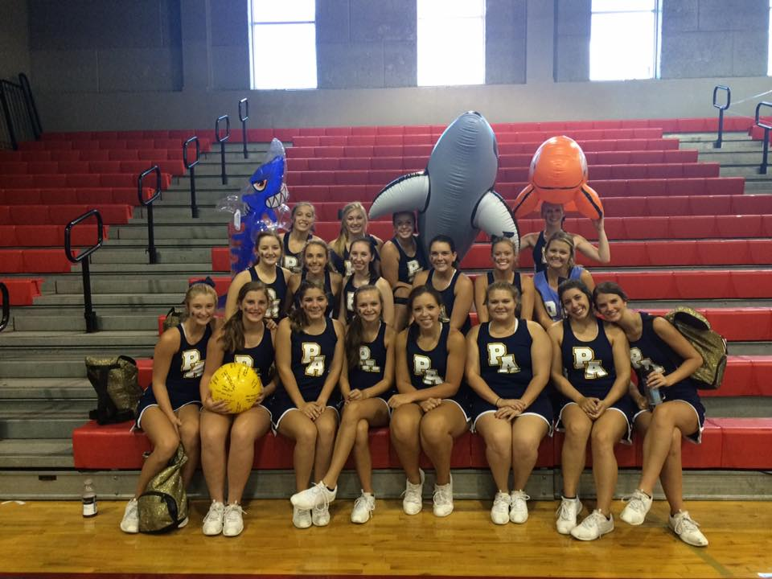

2016-2017

Varsity Cheerleaders!!

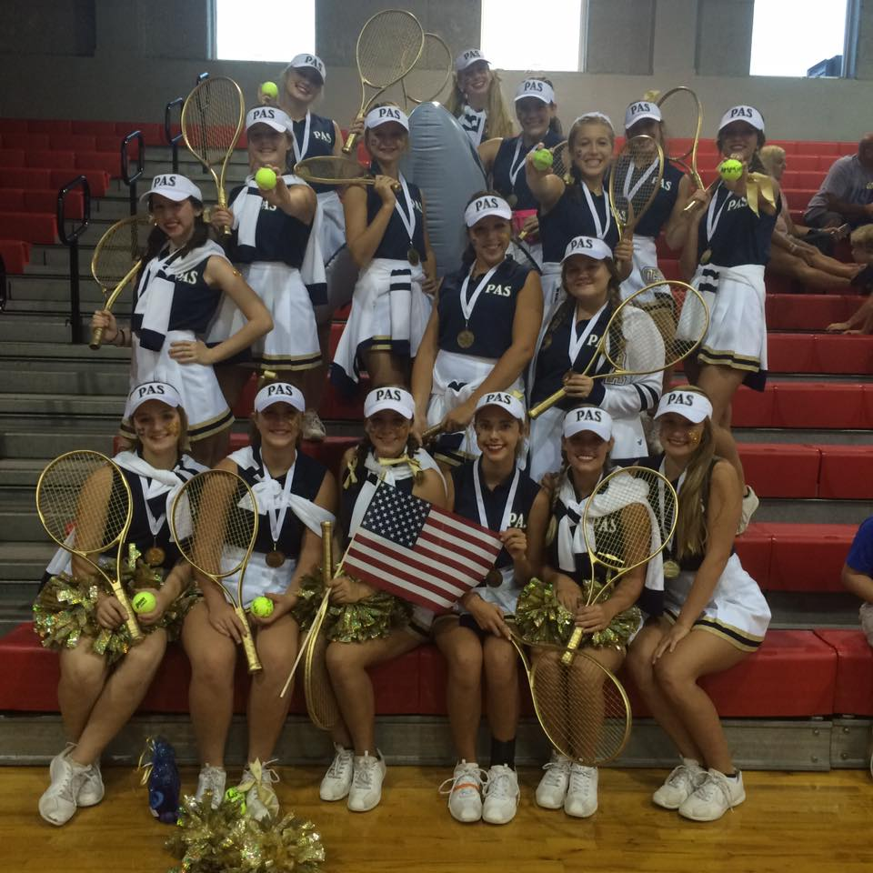

Got GOLD in everything at cheer camp this year. They did an awesome job!

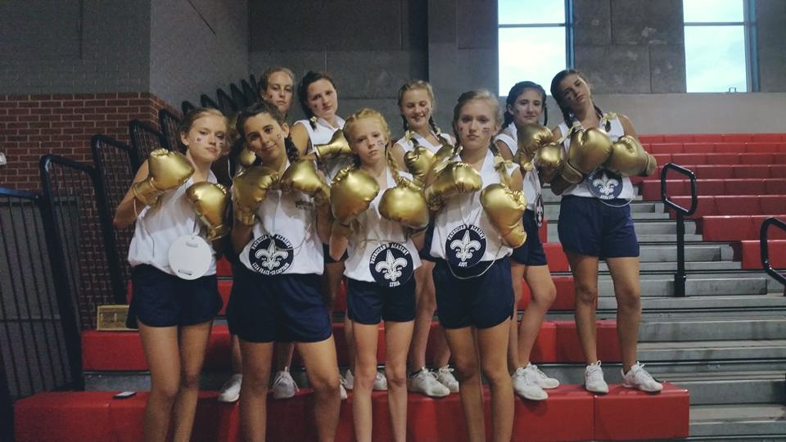

2016-2017

Junior Varsity Cheerleader

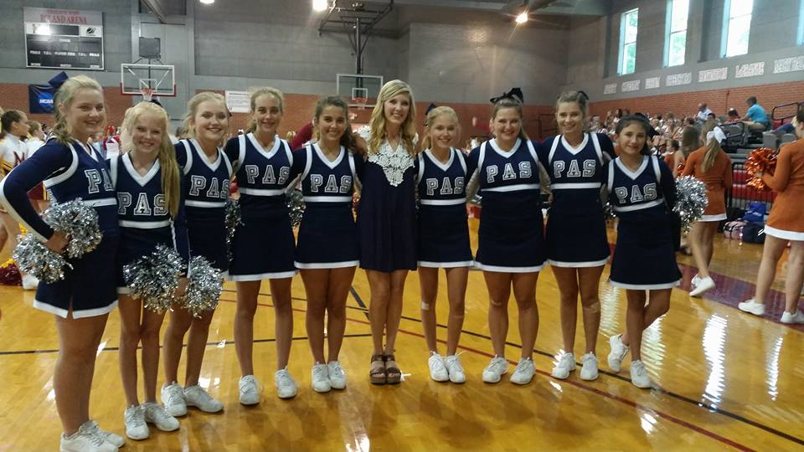

Won 4th in Home Pom and 2nd in extreme routine at champ this year!!

Way to go!!

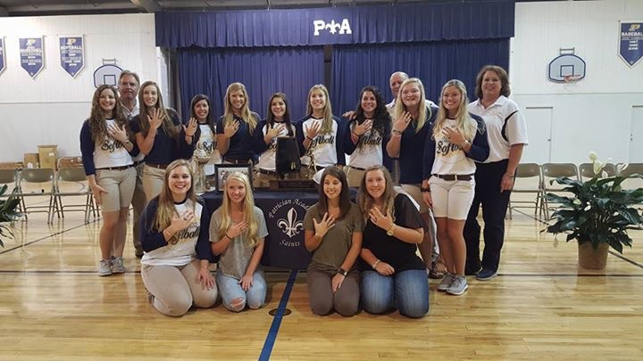

2016 Varsity Softball team came back home with state!! What a great group of girls!